**Business Requirement Document**

|  |  |  |
| --- | --- | --- |
| **1** | **Document Name** | **RSM website order placement** |
| **2** | **Initiated By** | **Mohammad Ahsan Ali Farooqui** |
| **3** | **Approver/s** |  |
| **4** | **BRD Prepared By** | **Omkar Ughade** |
| **5** | **Initiation Date** | **09-05-2025** |

***Table of Contents***

1. Objective 2

2. Key Acceptance Criteria 2

3. System users 2

4. Functionality: 3

A. BPP User 3

B. Customer 3

**Order placement functionality development**

# Objective

* To set up a functionality for order placements to be migrated from RSM website to tick pro plus with a successful SSO implementation.
* Set up a single login functionality on RSM website rather than providing two options like it does right now. Tick to be removed.

# Key Acceptance Criteria

* Equity order routing to be done through tick pro plus.
* Mutual Fund order routing to be done through tick pro plus.

# 

# Functionality:

* **Pre-Login Functionality:**
* Once the user lands on [https://www.reliancesmartmoney.com/](https://protect.checkpoint.com/v2/r05/___https://www.reliancesmartmoney.com/___.YXBzMTpyZWxpYW5jZWNhcGl0YWxsdGQ6YzpvOjIwNzM5ZTM1YzU0MzkxNjBhMTNiNDJkMmI1MGQyNGY0Ojc6YjUxMTo5YmYwZDZjMDlhMTJjMjM3MTZhY2Y0M2U0MjE4MDU0NDRjMTRjMjA5OGEwODczNDgzYjNhNTgyMTNmZDdhZGU3OnA6VDpG) , the user could click on either **Stocks** or **Mutual funds**. Ref. image below.



* Once the user would select Stocks🡪Bank, the user would be displayed the below list of options.

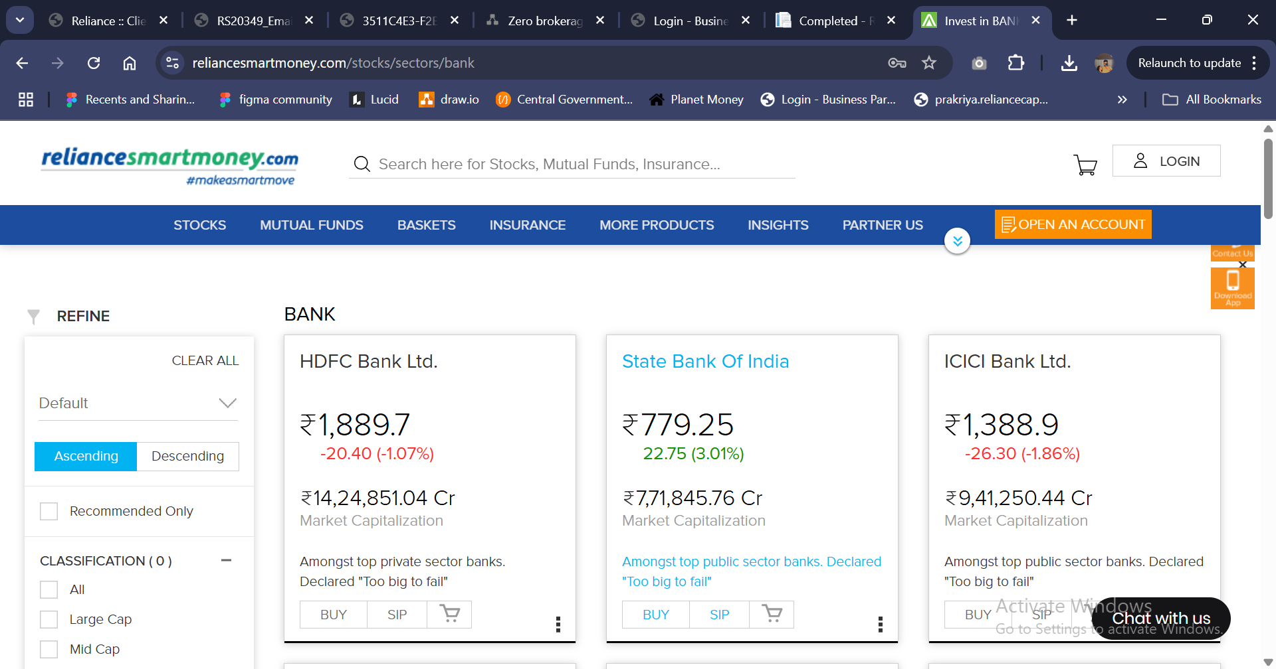

* Upon selecting a particular stock, the user would proceed with an option to buy where a login window would appear.

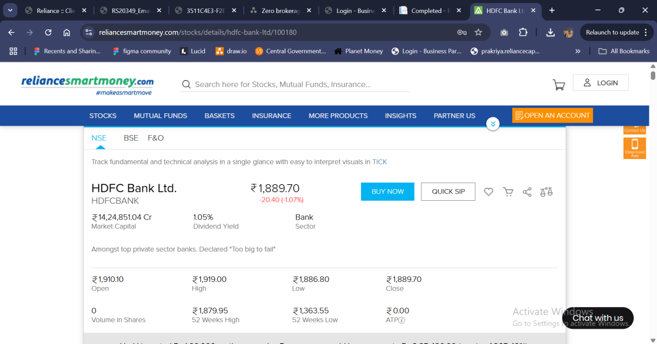

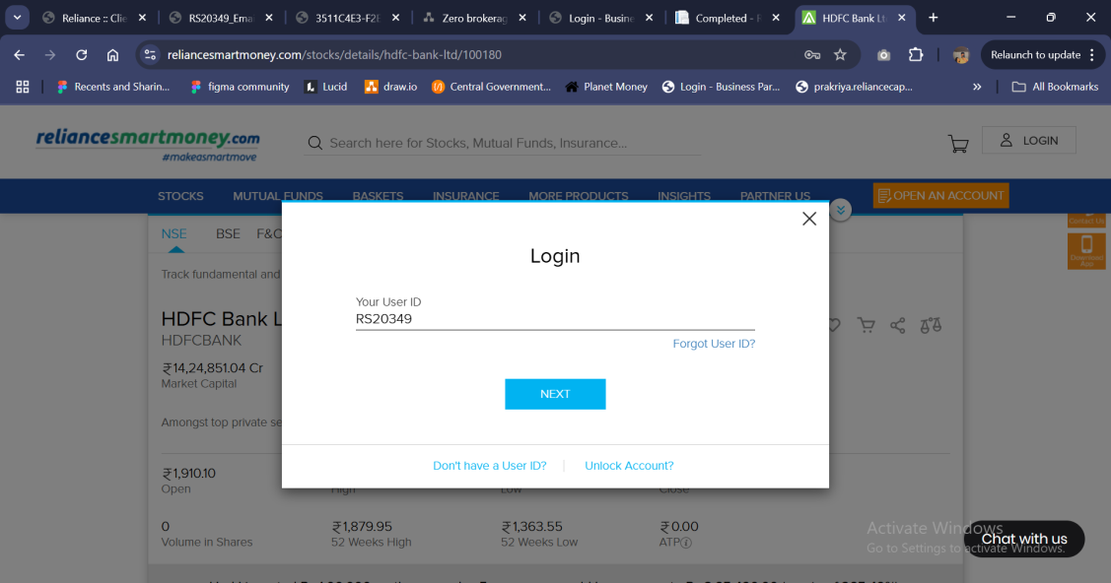

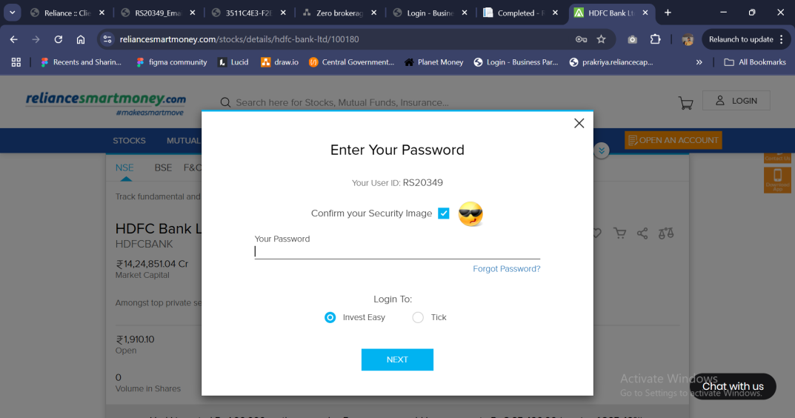

* Once login window appears, the user would enter their client code 🡪 Password 🡪 There would not be 2 platform options provided as it is provided in the current scenario.
* Once the user would enter their password and click submit, the user would be then redirected to tick pro plus.
* There would be a token based SSO login to bypass the authentication stage in tick pro plus.
* Simultaneously the user’s selected stock’s ISIN code should also be passed simultaneously.
* The user should then land on the tick pro plus screen as displayed below.

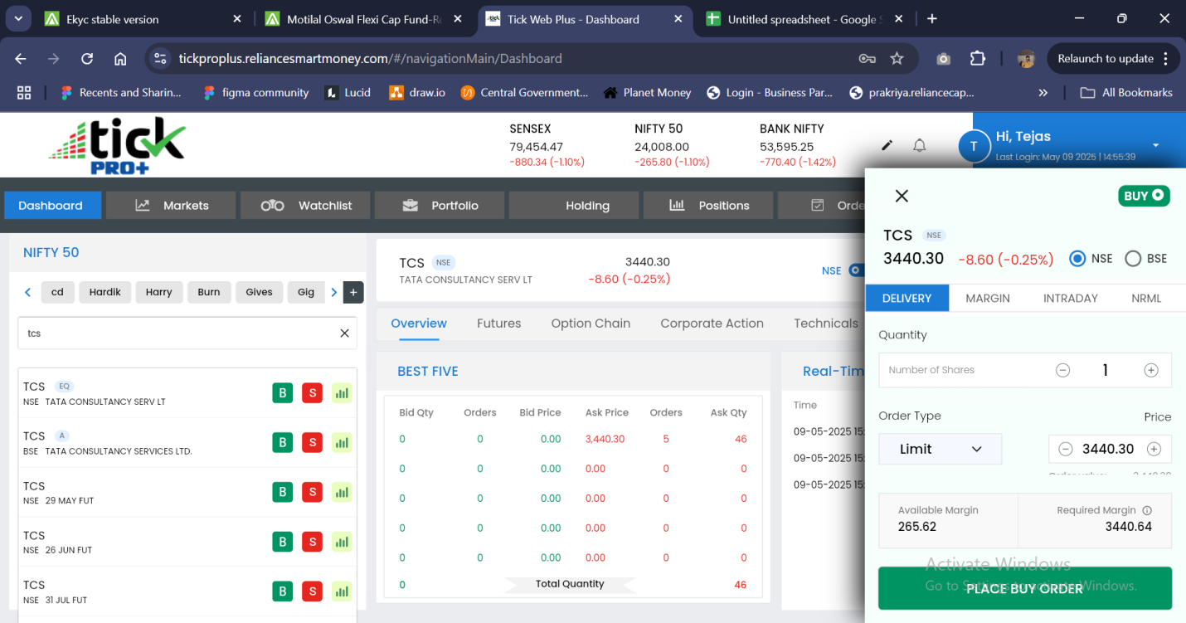

* The next journey should remain as-is in the tick pro plus application.
* Simultaneously for mutual funds once the user lands on the below mentioned screen, the user would select mutual funds.



* Once selected, the user would be displayed the same login pop-up as displayed in the stocks journey.
* Once logged in, the user should be then redirected to the Mutual funds page of tick pro plus.
* **Post Login functionality:**
* Once the user is logged (login functionality) to remain the same as above, once the user performs the above mentioned purchase/mutual funds journey, the user should bypass the login functionality using the SSO module and land on the purchase page as defined.